What type of site organization is used for the Pacific Trails Resort website?
- Hierarchical organization

Is it the most appropriate organization for the site? Why or why not?
- Yes, hierarchical is a great way to organize a website that is simple.

Cite three design practices that have been well implemented.
- Color is used consistently
  - The blue color palette makes me connect with water and a calm feeling.
- Navigation
  - The navigation bar is easy to use and functionable.
- Browser Compatibility
  - The files work on the current version of Google Chrome and Safari

Cite three design practices that could be implemented in a better way.
- Font inconsistently
  - I really like the font on the home page but on the activities page it is different. It makes it feel like a sperate project or coding error.
- Page layout
  - I sent the url to my cell phone to try it on mobile. Since we did not code the website to be mobile friendly it does not look right.
- Content Presentation
  - Images look outdated

How else would you improve the website?
- I would just make the website more modern to give it a good facelift. The page functions over all it just lacks the aesthetic appeal.

Second part:
Can you try to organize your pages using linear or random organization?
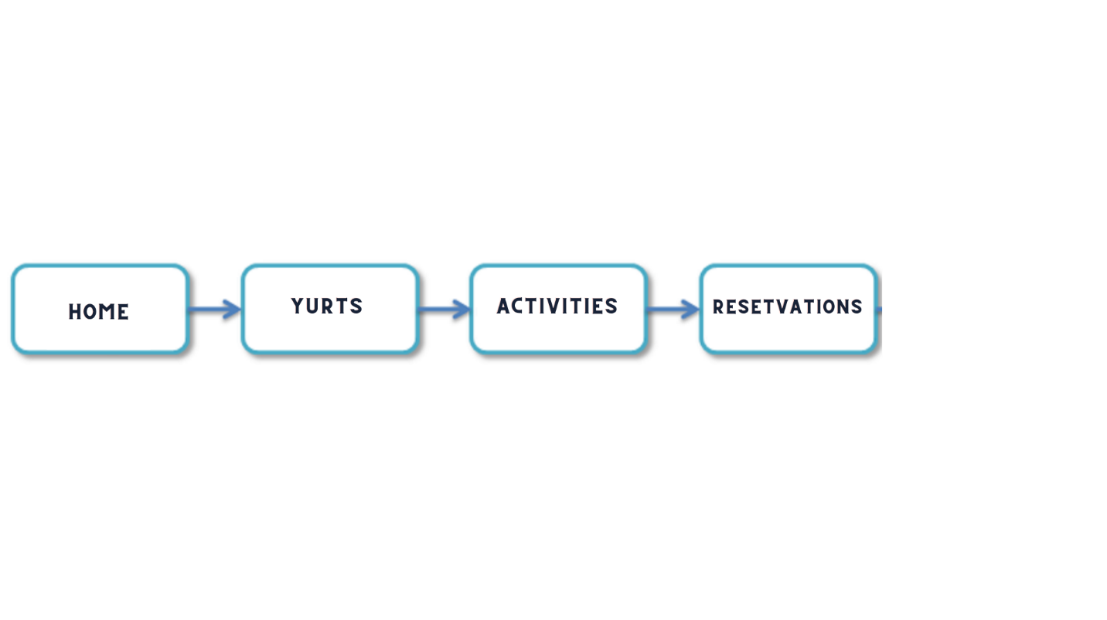
Please include your summary with either linear or random organization. Also, compare and contrast with which organization type was best fitted and which one was the most ill-suited?
Linear is the less confusing method out of the two options. I have chosen linear organization since it is a series site. Pacific Trails Resort tells a story. You have your home link that lure the consumer to keep looking. Next, is the Yurts link, which give the details of the luxury resort. Then, the activities link tells you all the fun things you can do while there. Finally, you have the reservation link or closing option to gain a sell. These sites flow together to like a great story.
If designing an art website was the goal for Pacific Trails resort, I would have gone with random organization. Random is the less common out of three because there is a lack of structure. Therefore, random is more ill-suited.

